

Report on internship at

**Department of Ocean Observation System (OOS)**

**NATIONAL INSTITUTE OF OCEAN TECHNOLOGY**



**SUBMITTED BY,**

***Sivasurya M* (RA2311004020094)**

***Suganth M* (RA2311004020097)**

***Sanjeeva S* (RA2311004020085)**

**Department** : Electronics and Communication Engineering

**Duration :** 10.06.2025 to 10.07.2025

|  |  |  |
| --- | --- | --- |
| S.No | Topics | Page No. |
| 1. | Acknowledgement | 3 |
| 2. | Summary | 4 |
| 3. | National Institute of Ocean Technology(NIOT) | 5 |
| 4. | Ocean Observation System (OOS)Division - NIOT | 7 |
| 5. | Introduction | 8 |
| 6. | Literature Review | 9 |
| 7. | System Overview | 10 |
| 8. | Components Used | 11 |
| 9. | Block Diagram | 13 |
| 10. | Circuit Connection | 14 |
| 11. | Working Principle | 17 |
| 12, | Hardware Implementation | 21 |
| 13. | Code & Explanation | 24 |
| 14. | Conclusion | 27 |

**Table of Content**

**Acknowledgement**

We sincerely thank **Dr.M.Sakthi Ganesh**,Dean ,**Dr.N.V.S. Sree Rathna Lakshmi,M.E., Ph.D**. Head of the Department, **Dr.K.Kavitha Devi ,**Assistant Professor,SRM institute of science and technology, Ramapuram , Department of Electronics and Communication for their support to do our internship at National Institute of Ocean Technology

We express our gratitude to **Prof. Balaji Ramakrishnan**, Director of National Institute of Ocean technology(NIOT) for allowing us to do our internship in this prestigious organization. We are extremely grateful to the staff of National Institute of Ocean Technology (NIOT) especially Ocean Observatory Systems(OOS) for arranging this one month offline internship and to the staff who provided us enlightenment of knowledge and guided us to see the fruitful outcomes of the internship conducted. Everything they taught us was useful and the information conveyed is efficient. We are thankful to the faculty who informed us about this internship conducted by NIOT.

We would like to thank **Mr.M. Arul Muthiah** (Scientist - F) Group Head, and **Mr. Biswajit Haldar** (Scientist D) at Ocean Observation System group, for enlightening us with their knowledge and for his efforts in bringing workshop experts for various sessions.

Our sincere thanks to **Mr.Sundar Jesuraj Sabastion**, Scientific officers of NIOT, for giving us valuable ideas, time, and care and for always porting us by showing the right direction.

I Thank **Dr.N.R Ramesh**, **Dr.Palaniappan**, **Ms. R.Ragini**, HR Department for selecting me to complete the internship.

My sincere thanks to **Mr. D Sachin Kumar**, Project Scientist I of NIOT, for giving me valuable ideas, time, and care and for always supporting me by showing the right direction.

**SUMMARY**

We had the opportunity to pursue an internship at the **National Institute of Ocean Technology (NIOT)**, located in **Pallikaranai, Chennai**, under the **Ocean Observation Systems (OOS) Division**. This internship served as a significant milestone in our academic journey, providing me with practical exposure to real-time marine and power management systems.

Over the course of my internship, We was actively involved in understanding and working on technologies used in ocean observation platforms, power supply systems, and embedded systems integration. we was guided by expert engineers and researchers who helped us explore various interdisciplinary domains, including electronics, microcontroller programming, sensor interfacing, and renewable energy applications.

As part of my internship task, We worked on a hands-on project titled **"Smart Battery Switching and Monitoring System using ESP32"**. This system was designed to automatically manage power supply sources—specifically solar energy, lead-acid, and lithium-ion batteries—to ensure efficient energy usage and uninterrupted load operation. I also developed a monitoring interface to track current and voltage values from different power sources, and implemented safety measures such as diodes and fuses to protect the system.

This internship not only enhanced our technical skills in embedded systems and circuit design, but also taught me valuable lessons in system safety, data monitoring, and power electronics. It was a truly enriching experience that bridged the gap between academic knowledge and industrial practice.

## **National Institute of Ocean Technology (NIOT)**



### **Introduction**

The **National Institute of Ocean Technology (NIOT)** was established in **November 1993** as an autonomous society under the **Ministry of Earth Sciences (MoES), Government of India**. It is headquartered at **Pallikaranai, Chennai**, and functions as a premier institute dedicated to the development of technologies related to the sustainable utilization of ocean resources.The primary goal of NIOT is to develop reliable and indigenous technologies for ocean-related applications, particularly within the Indian Exclusive Economic Zone (EEZ), and to support strategic and commercial interests in marine and coastal environments.

### **Vision**

### To develop reliable indigenous technologies to solve the engineering challenges associated with the sustainable exploitation of ocean resources and contribute to national development and self-reliance in ocean technology.

### **Mission**

1. To develop world-class technologies and their applications for sustainable utilization of ocean resources.
2. To provide value-added technical services and solutions to organizations involved in marine and coastal activities.
3. To enhance institutional capacity and knowledge base in the field of ocean engineering, observation systems, and marine technology.

### **Key Objectives**

* **Development of Ocean Observation Systems**: Design and deployment of moored buoys, drifting buoys, and other ocean observation platforms for continuous environmental data collection.
* **Renewable Ocean Energy**: Research and development of wave energy, ocean thermal energy conversion (OTEC), tidal energy, and seawater-based desalination systems.
* **Deep Sea Technologies**: Development of subsea systems, including mining technologies for deep-sea resources such as polymetallic nodules and gas hydrates.
* **Underwater Vehicles**: Design and deployment of Remotely Operated Vehicles (ROVs), Autonomous Underwater Vehicles (AUVs), and manned submersibles for deep-sea exploration and monitoring.
* **Coastal and Environmental Engineering**: Development of shoreline protection techniques, sediment transport models, and coastal zone management technologies.
* **Marine Biotechnology**: Studies on marine microbial and algal strains, open-sea cage aquaculture, ballast water treatment, and biofouling prevention.
* **Desalination Technologies**: Implementation of low-temperature thermal desalination (LTTD) plants in island and coastal regions to provide fresh water using ocean thermal gradients.
* **Technology Transfer and Capacity Building**: Promoting skill development, technology dissemination, and academic-industry collaboration in ocean science and technology.

## **Ocean Observation Systems (OOS) :**



### **Introduction**

The **Ocean Observation Systems (OOS)** division is one of the core functional units of the **National Institute of Ocean Technology (NIOT)**. It plays a vital role in the **systematic and continuous monitoring of oceanographic and meteorological parameters** in the Indian seas and surrounding oceanic regions. The division is responsible for the **design, development, deployment, and maintenance of observational platforms** that provide real-time and long-term data for scientific, operational, and commercial applications.

### **Purpose and Scope**

The primary aim of the OOS division is to enable **data-driven ocean research and forecasting** by deploying **reliable, robust, and long-term ocean observing systems**. These systems are crucial for:

* Weather and climate forecasting
* Cyclone and tsunami warnings
* Fisheries management
* Marine ecosystem studies
* Navigation and offshore operations

### **Key Activities**

1. **Design and Development of Observation Platforms**
   1. Moored buoys (OMNI, DPDB, Tsunami Buoys)
   2. Drifting buoys
   3. Tide gauges
   4. Autonomous platforms such as ARGO floats and Gliders
2. **Ocean Data Collection**
   1. Real-time and delayed-mode data on sea surface temperature, salinity, currents, wave height, wind speed/direction, atmospheric pressure, etc.
   2. Data acquisition using satellite communication systems such as INSAT and Iridium.
3. **Deployment and Maintenance**
   1. Regular deployment and retrieval operations in the Arabian Sea, Bay of Bengal, and the Indian Ocean.
   2. Collaboration with Indian Navy, Coast Guard, and scientific vessels for offshore missions.
4. **Data Processing and Dissemination**
   1. Validation, calibration, and archiving of acquired data.
   2. Dissemination through the **INCOIS (Indian National Centre for Ocean Information Services)** and other agencies for operational forecasting and research use.
5. **Collaborations and National Missions**
   1. Supporting programs such as the Indian Tsunami Warning System, Ocean Moored Buoy Network, and Regional Integrated Multi-hazard Early Warning System (RIMES).

### **INTERNSHIP PROJECT :**

### **Chapter 1: Introduction**

#### **Background**

With the increasing need for real-time ocean monitoring and early warning systems, ocean buoys have become a critical platform for collecting environmental data. These systems are deployed in remote offshore locations where access to grid power is not possible. Therefore, efficient power management using renewable energy sources like solar panels, combined with smart battery systems, is essential. Institutions such as NIOT use such buoys to support oceanographic sensors, communication modules, and data loggers. Since solar energy availability is inconsistent due to weather and daylight variability, reliable battery switching and energy monitoring are required to maintain uninterrupted operation of the buoy systems

#### **1.2 Objective**

This project addresses the challenge by:

* Monitoring the voltage and current of all sources
* Automatically switching between batteries based on real-time voltage thresholds
* Providing on-site voltage/current display via a 16x4 LCD
* Ensuring circuit safety with diodes and fuses
* Using a buck converter to regulate ESP32 voltage

#### **1.3 Problem Statement**

Manual switching between batteries can lead to energy loss and system failure in critical environments. An automatic microcontroller-based decision system improves reliability and reduces human intervention.

## **Chapter 2: Literature Review**

### **2.1 Smart Energy Management Systems**

Over the past decade, research into off-grid solar and battery management systems has increased. These systems are vital in regions with unreliable grid access or in remote locations such as marine, military, or agricultural sites. Smart energy systems automate source selection, reduce manual maintenance, and extend battery life through intelligent decision-making.

### **2.2 Microcontroller-Based Switching**

Many researchers have implemented switching systems using microcontrollers like Arduino, STM32, or ESP32. These systems offer flexibility through programmable thresholds and can switch between sources such as solar, battery, and grid. Comparatively, the ESP32 stands out due to its built-in Wi-Fi, high processing power, and analog input capabilities — ideal for both switching and monitoring applications.

### **2.3 Current and Voltage Monitoring Techniques**

Current sensors like the **ACS712** are widely used due to their:

* Bidirectional sensing capability
* Isolation from high voltage systems
* Compatibility with microcontrollers

Voltage monitoring is often achieved using:

* Voltage divider circuits

### **2.4 Related Works and Gaps**

Existing works mainly focus on either:

* Switching without monitoring, or
* Monitoring without control features.

This project fills the gap by integrating **monitoring and switching**, while also enhancing safety with **fuses, diodes**, and **a buck converter** for regulation — a critical requirement in harsh environments like NIOT’s offshore platforms.

## **Chapter 3: System Overview**

### **3.1 Project Summary**

This project creates an intelligent power management system that:

* Automatically switches between **Lead-Acid (12.5V)** and **Lithium-Ion (14V)** batteries using a relay
* Measures voltage and current of 4 channels: **Solar Panel**, **Lead-Acid Battery**, **Lithium-Ion Battery**, and **Load**
* Displays all data on a **16x4 I2C LCD**
* Optionally allows expansion to Wi-Fi monitoring

**3.2 Use Case Scenario**

In NIOT field deployments, a buoy with solar panel charges the lead-acid battery during the day. If solar output fails or lead-acid voltage drops below 12V, the system must switch to lithium-ion backup — this project simulates and automates that behavior.

### **3.3 System Goals**

* Improve operational efficiency in remote power setups
* Reduce manual interventions
* Monitor system health in real-time
* Enable scalability through modular hardware design

## **Chapter 4: Components Used**

This chapter outlines the electronic components used to build the Smart Battery Switching and Monitoring System. Each component is carefully selected for functionality, accuracy, and cost-effectiveness.

### **4.1 ESP32 Dev Board (WROOM)**

* A powerful dual-core microcontroller with built-in Wi-Fi and Bluetooth
* 3.3V logic level and multiple ADC pins for analog sensing
* Acts as the brain of the system, handling sensing, logic, relay control, and display

### **4.2 ACS712 Current Sensors (×4)**

* Measures bidirectional current (up to 20A)
* Analog voltage output (centered around 2.5V)
* Used to monitor:
  + Solar panel current
  + Lead-acid battery current
  + Lithium-ion battery current
  + Load current

**4.3 Voltage Divider:**

* A voltage divider is a simple resistor circuit that reduces a high voltage to a lower level. It’s used to safely measure voltages with ESP32, which only accepts up to 3.3V on its ADC pins.
* How it Works: Two resistors are connected in series. The voltage at the junction is:
* Vout = Vin * (R2 / (R1 + R2))
* The reduced voltage is sent to the ESP32 analog pin. Software calculations are used to convert the measured value back to the original voltage.
* Example: If ESP32 reads 2.5V, and the scale factor is 5.5, the actual voltage ≈ 13.75V..

### **4.4 Relay Module (1-Channel, 5V)**

* Electromechanical switch controlled by ESP32 GPIO
* Used to switch the load between lead-acid and lithium-ion batteries based on voltage threshold
* Can handle high current loads (10A or more)

### **4.5 LED Bulb (Load)**

* Acts as the output load
* Power drawn is measured using current sensor
* Represents a typical small field equipment (light, sensor, etc.)

### **4.6 16x4 I2C LCD Display**

* Used to display voltage and current readings in real time
* I2C interface minimizes required ESP32 GPIO pins (typically GPIO21 & GPIO22)

### **4.7 Diodes (1N5408)**

* High current diodes for blocking reverse current
* Prevents batteries from discharging into other sources
* Used on each power source output

### **4.8 Fuses**

* 5A or 10A rating based on source/load requirements
* Provides overcurrent protection to each line
* Enhances circuit safety

### **4.9 Buck Converter (MP1584)**

* Adjustable voltage regulator (step-down)
* Converts high input voltage (12V–14V) to 5V or 3.3V
* Powers the ESP32, sensors, and relay safely

### **4.10 Solar Panel**

* Provides renewable energy input (usually 12V rated)
* Charges lead-acid battery via a charge controller

### **4.11 Lead-Acid Battery (12.5V)**

* Primary battery source for powering load
* If voltage drops below 12V, system switches to lithium-ion

**4.12 Lithium-Ion Battery (14V)**

* Secondary battery used when the lead-acid battery fails or drops below threshold
* Supplies the load when triggered by ESP32 via relay

### **4.13 Solar Charge Controller**

* Regulates the voltage and current coming from the solar panel
* Ensures safe charging of the lead-acid battery
* Prevents overcharging, reverse current, and deep discharge
* Acts as an intermediate power distribution system to both battery and load

## **Chapter 5: Block Diagram**

The system is divided into modular blocks for clarity and better understanding.

### **5.1 Functional Block Description**

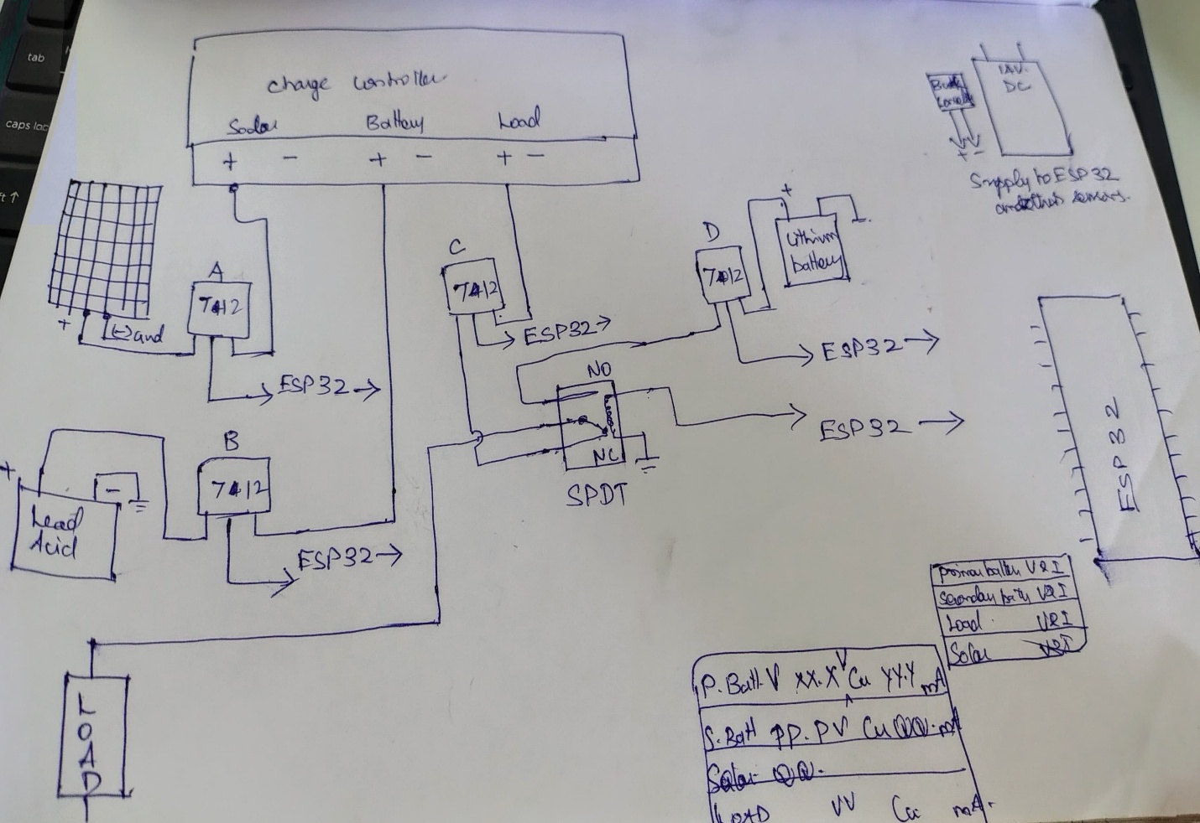

## **Chapter 6: Circuit Connections**

### **6.1 Overview**

This circuit includes:

* Power source connections
* Current & voltage sensor wiring
* Relay control logic
* Buck converter integration
* I2C LCD interface

### **6.2 Connections Summary (Textual Description)**

#### **Current Sensors (ACS712 x4)**

|  |  |  |  |
| --- | --- | --- | --- |
| **Sensor** | **VCC** | **GND** | **OUT (to ESP32 GPIO)** |
| Solar Panel Current | 5V | GND | GPIO32 |
| Lead-Acid Current | 5V | GND | GPIO33 |
| Lithium-ion Current | 5V | GND | GPIO34 |
| Load Current | 5V | GND | GPIO35 |

#### **Voltage Sensors (x4)**

|  |  |  |  |
| --- | --- | --- | --- |
| **Sensor** | **VCC** | **GND** | **OUT (to ESP32 GPIO)** |
| Solar Panel Voltage | 5V | GND | GPIO36 |
| Lead-Acid Voltage | 5V | GND | GPIO39 |
| Lithium-ion Voltage | 5V | GND | GPIO25 |
| Load Voltage | 5V | GND | GPIO26 |

All sensors are powered via **buck converter (MP1584)** set to 5V output.

#### **Relay Module (1-Channel)**

|  |  |
| --- | --- |
| **Pin** | **Connected To** |
| IN | GPIO27 (ESP32) |
| VCC | 5V (from buck) |
| GND | GND (common ground) |
| NO (Normally Open) | Load +ve wire (if battery is active) |
| COM | Load +ve input |

#### **I2C LCD (16x4)**

|  |  |
| --- | --- |
| **LCD Pin** | **ESP32 Pin** |
| SDA | GPIO21 |
| SCL | GPIO22 |
| VCC | 5V from buck |
| GND | GND |

#### **Battery + Power Flow**

* **Solar Panel** → Diode + Fuse → Charge Controller → Lead-Acid Battery
* **Lead-Acid Battery** → Relay → Load
* **Lithium Battery** → Relay → Load
* Both battery outputs are also tapped to sensors

#### **Buck Converter (MP1584)**

* **Input:** From any 12V battery
* **Output:** 5V regulated to power ESP32, Relay & Sensors

**6.3 Diagram (Image Attached Below)**

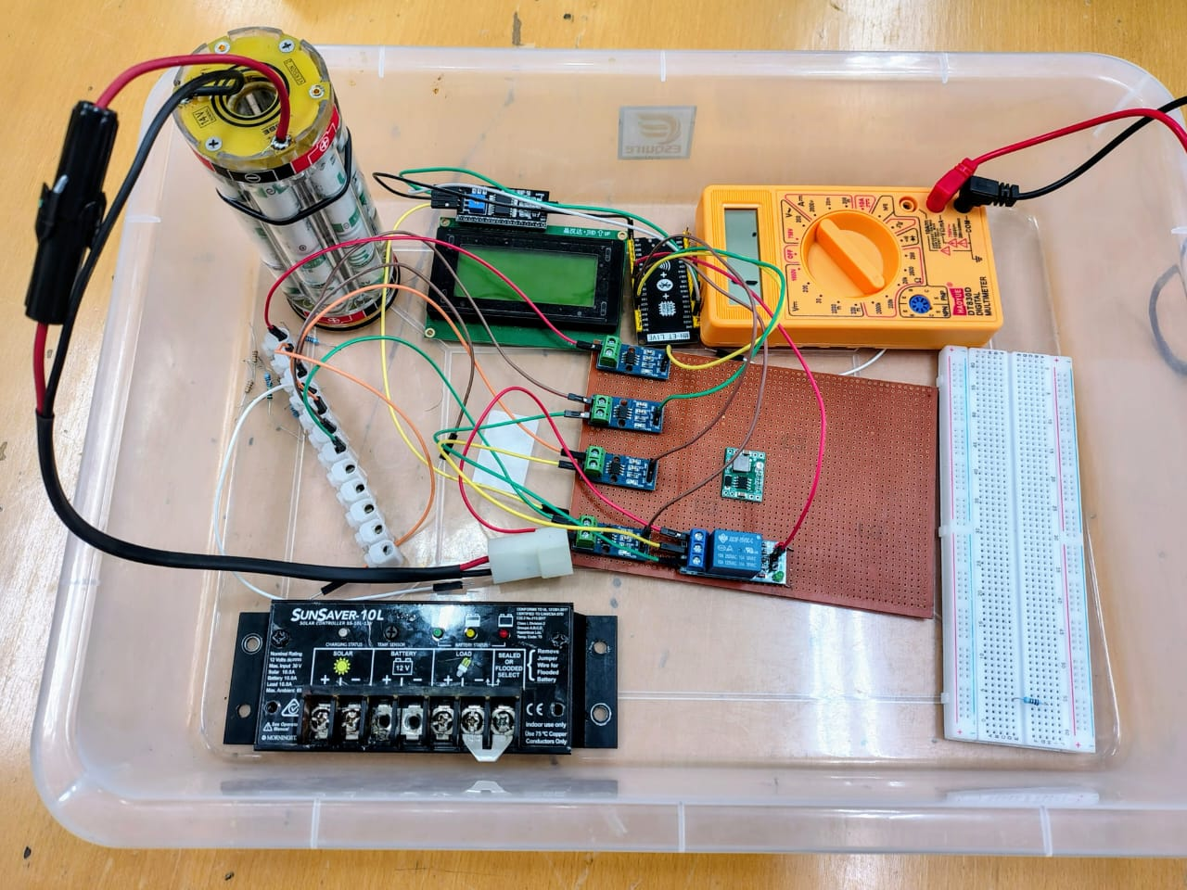

# **Chapter 7: Working Principle**

This chapter describes in depth how the Smart Battery Switching and Monitoring System functions. The system is designed to intelligently manage power from renewable and conventional battery sources, ensuring safe and uninterrupted energy supply while continuously monitoring real-time voltage and current values. The explanation below includes data acquisition, switching logic, display mechanism, and safety elements such as the solar charge controller, fuses, diodes, and buck converter.

## **7.1 Power Source Monitoring**

At the heart of the system is the **ESP32 microcontroller**, which reads analog data from both **voltage and current sensors** to assess the condition and availability of each power source:

* **Voltage Sensors (x4):** Each voltage sensor is connected to a high-voltage source (solar panel, lead-acid battery, lithium-ion battery, and load). These sensors contain internal resistive voltage dividers that safely reduce high input voltages (up to 25V) to levels readable by the ESP32's analog GPIO pins. The raw analog values are mapped using custom formulas in the code to display the actual voltage values.
* **Current Sensors (ACS712 x4):** The ACS712 sensors output a voltage signal centered at 2.5V (when current is zero). When current flows through the sensor, the output voltage shifts proportionally. The ESP32 reads this output and uses calibration formulas to calculate the actual current.
* **Continuous Monitoring:** The ESP32 continuously reads and processes these sensor values within the main loop of the code. Readings are refreshed every second, providing up-to-date insights into system behavior.

## **7.2 Smart Switching Logic**

A key feature of this system is its **automated load switching mechanism** using a **relay module**. The objective is to prioritize power from the lead-acid battery but prevent it from discharging below 12V, which could damage the battery.

The ESP32 constantly checks the voltage level of the **Lead-Acid Battery**.

* **If voltage is ≥ 12.0V:**
  + The relay remains in its default state (Normally Open closed via control), connecting the **Lead-Acid Battery** to the load.
  + The Lithium-ion battery remains idle.
* **If voltage falls below 12.0V:**
  + The ESP32 triggers the relay to switch states.
  + The **Lithium-ion Battery** becomes the active source.
  + This prevents deep discharge of the lead-acid battery and ensures uninterrupted load operation.
* The switching is seamless and safe, with no human intervention required.
* The logic is implemented in code and can be easily modified to add hysteresis or other logic improvements.

## **7.3 Display and Monitoring System**

A **16x4 I2C LCD Display** is used to show real-time voltage and current readings from all sources, as well as the active power source status.

* **I2C Interface:** The LCD is connected using just two wires (SDA and SCL), conserving ESP32 pins.
* **Display Cycle:**
  + The ESP32 formats sensor data and updates the display every second.
  + If required, scrolling or page-switching logic can be added for more advanced viewing.
* **Example Output on LCD:**
* 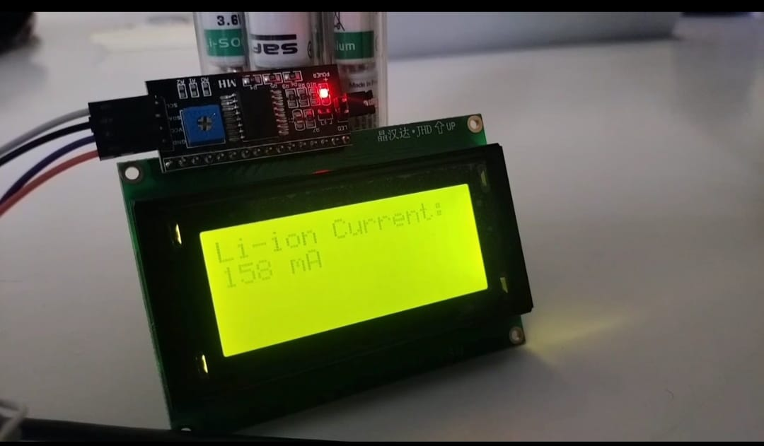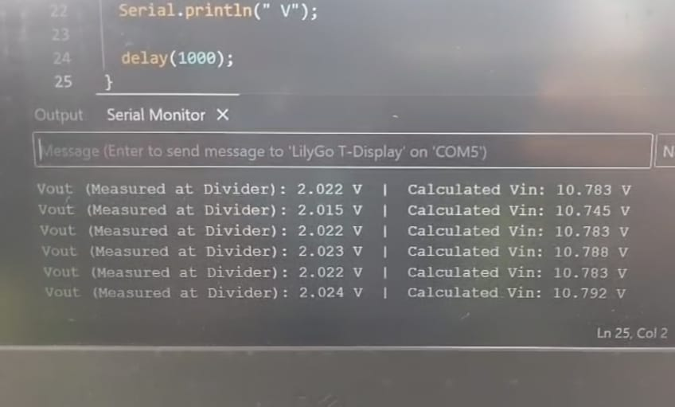

Solar: 13.1V 1.2A  
Lead: 12.6V 2.1A  
Lithium: 13.9V 0.0A  
Load: 11.8V 2.2A  
Source: Lead-Acid

* This provides clear insight into energy flow and source status, which is extremely useful for both monitoring and debugging.

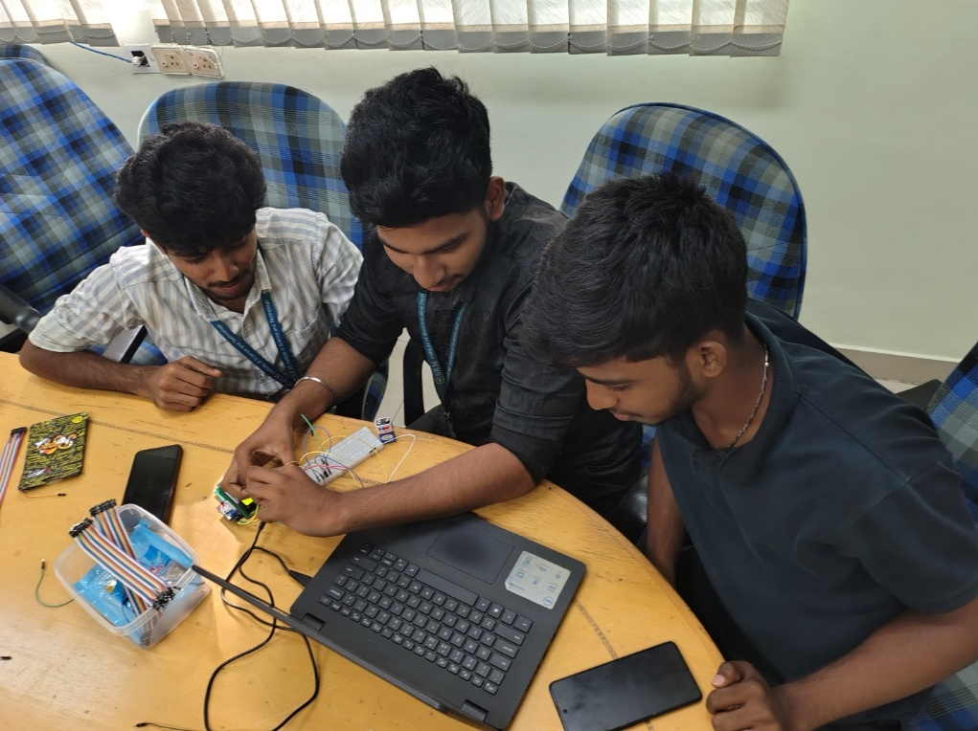

## **7.4 Safety Systems and Power Distribution**

### **Solar Charge Controller**

* **Function:** The solar charge controller regulates the power from the solar panel before charging the lead-acid battery.
* **Purpose:** Prevents overcharging, under-voltage, and backflow of current from the battery to the panel.
* **Load Mounting:** In this system, the load is also connected through the charge controller's load terminal (if supported), allowing it to cut off load power if the battery voltage drops too low.

### **Diodes (1N5408)**

* Prevent reverse current flow from one battery into another or from the battery back into the solar panel.
* Placed at the positive terminals of each power source before connection to the rest of the circuit.
* Ensures unidirectional power flow and protects components.

### **Fuses (5A/10A)**

* Placed in series with each power line (solar, lead-acid, lithium, and load).
* If current exceeds safe limits, the fuse blows and disconnects that section, preventing circuit damage or fire.
* Essential for protecting both the components and the wiring infrastructure.

### **Buck Converter (MP1584)**

* Steps down high input voltage (12V–14V) from batteries to a safe **5V output**.
* Powers the ESP32, LCD, and sensors.
* This is critical because ESP32 operates at 3.3V logic and the peripherals operate at 5V.

## **Summary of Operation**

1. Solar panel charges the lead-acid battery through the charge controller.
2. ESP32 continuously monitors voltage and current of all sources.
3. Load draws power from lead-acid battery if voltage is healthy.
4. When lead-acid battery voltage drops below 12V, ESP32 triggers relay to switch to lithium battery.
5. Current and voltage values are displayed in real-time on the LCD.
6. All circuits are protected with fuses, diodes, and voltage regulation for maximum safety.

This smart system ensures **uninterrupted, efficient, and safe operation** using renewable and stored energy.

# **Chapter 8: Hardware Implementation**

This chapter elaborates on the practical aspects of assembling and deploying the Smart Battery Switching and Monitoring System. It covers the layout of the physical hardware, best practices for safe and stable wiring, and suitable packaging methods to make the system deployment-ready for real-world applications.

## **8.1 Physical Setup**

The entire system is assembled initially on a **breadboard** for testing and later transitioned to a **perfboard** for better mechanical stability.

* Components like the ESP32, relay, and sensors are placed on the perfboard in a structured layout.
* All connections strictly follow the finalized **schematic diagram**, which includes:
  + ACS712 current sensors
  + Voltage sensor modules
  + Relay module
  + I2C LCD display
  + Diodes and fuses
  + Buck converter (MP1584)
  + Integration with solar charge controller and batteries
* The **solar charge controller** is physically positioned near the lead-acid battery and solar panel and is connected using thick power wires.
* Real power sources like **14V lithium-ion battery**, **12.5V lead-acid battery**, and a **solar panel** are connected using **screw terminals** for robust connections.

## **8.2 Wiring Practices**

For reliability and safety, the following wiring practices are adopted:

* **Common Ground:**
  + All components including ESP32, current sensors, voltage sensors, buck converter, relay, and the power sources share a common ground. This avoids signal inconsistencies and reference errors in analog readings.
* **Power Wires:**
  + High-current paths like battery connections and load connections are made using **thicker gauge wires (e.g., 18 AWG or 16 AWG)** to handle the current load safely.
  + Low-power control and signal wires use jumper wires with secure soldered connections or dupont connectors.
* **Sensor Wiring:**
  + Sensor outputs (ACS712 and voltage dividers) are routed carefully to avoid cross-talk and signal noise.
  + Voltage sensor outputs go to ESP32 ADC pins; current sensors (ACS712) are centered around 2.5V and read via separate ADCs.
* **Connection Safety:**
  + **Screw terminals** are used for battery and solar panel connections.
  + **Heat-shrink tubing** or **tape insulation** is applied to all high-voltage exposed solder joints.
  + All components are labeled for easy identification during field use.

## **8.3 Packaging & Powering**

* The **ESP32** and all sensors are powered via a **buck converter (MP1584)** that steps down voltage from 12V/14V sources to a stable **5V output**.
* The **ESP32 is connected directly to the 5V rail** of the buck converter using its VIN (or 5V) and GND pins.
* The relay and sensors also draw power from this same regulated 5V rail.
* The **solar panel is connected to the charge controller**, which in turn charges the **lead-acid battery**. The **load is mounted through the charge controller's load output** (if supported) for added protection and regulation.
* All components including the ESP32, sensors, and relay are mounted on a **perforated board** or **custom PCB** and optionally enclosed in a **plastic or acrylic casing** with cut-outs for ventilation and connectors.
* For field deployment, the enclosure may include:
  + Transparent window for LCD visibility
  + External terminals for batteries and load
  + Reset and boot buttons for ESP32

This implementation ensures the system is robust, testable, and safely deployable in real-world environments such as the National Institute of Ocean Technology (NIOT), where this project is being executed.

## **Chapter 9: Complete Code and Explanation**

#include <Wire.h>

#include <LiquidCrystal_I2C.h>

LiquidCrystal_I2C lcd(0x27, 16, 4);

const int solarCurrentPin = 32;

const int leadCurrentPin = 33;

const int lithiumCurrentPin = 34;

const int loadCurrentPin = 35;

const int solarVoltagePin = 36;

const int leadVoltagePin = 39;

const int lithiumVoltagePin = 25;

const int loadVoltagePin = 26;

const int relayPin = 27;

void setup() {

Serial.begin(115200);

lcd.init();

lcd.backlight();

pinMode(relayPin, OUTPUT);

digitalWrite(relayPin, LOW);

}

float readCurrent(int pin) {

int sensorValue = analogRead(pin);

float voltage = (sensorValue * 3.3) / 4095.0;

float current = (voltage - 2.5) / 0.066;

return current;

}

float readVoltage(int pin) {

int sensorValue = analogRead(pin);

float voltage = (sensorValue * 3.3) / 4095.0;

float realVoltage = voltage * (25.0 / 3.3);

return realVoltage;

}

void loop() {

float solarCurrent = readCurrent(solarCurrentPin);

float leadCurrent = readCurrent(leadCurrentPin);

float lithiumCurrent = readCurrent(lithiumCurrentPin);

float loadCurrent = readCurrent(loadCurrentPin);

float solarVoltage = readVoltage(solarVoltagePin);

float leadVoltage = readVoltage(leadVoltagePin);

float lithiumVoltage = readVoltage(lithiumVoltagePin);

float loadVoltage = readVoltage(loadVoltagePin);

String powerSource = "";

if (leadVoltage < 12.0) {

digitalWrite(relayPin, HIGH);

powerSource = "Lithium-ion";

} else {

digitalWrite(relayPin, LOW);

powerSource = "Lead-Acid";

}

Serial.println("---- SYSTEM READINGS ----");

Serial.printf("Solar: %.2fV %.2fA\n", solarVoltage, solarCurrent);

Serial.printf("Lead: %.2fV %.2fA\n", leadVoltage, leadCurrent);

Serial.printf("Lithium: %.2fV %.2fA\n", lithiumVoltage, lithiumCurrent);

Serial.printf("Load: %.2fV %.2fA\n", loadVoltage, loadCurrent);

Serial.printf("Source: %s\n", powerSource.c_str());

lcd.setCursor(0, 0);

lcd.printf("S:%.1fV %.1fA", solarVoltage, solarCurrent);

lcd.setCursor(0, 1);

lcd.printf("L:%.1fV %.1fA", leadVoltage, leadCurrent);

lcd.setCursor(0, 2);

lcd.printf("B:%.1fV %.1fA", lithiumVoltage, lithiumCurrent);

lcd.setCursor(0, 3);

lcd.printf("Src:%s", powerSource.c_str());

  delay(2000);

}

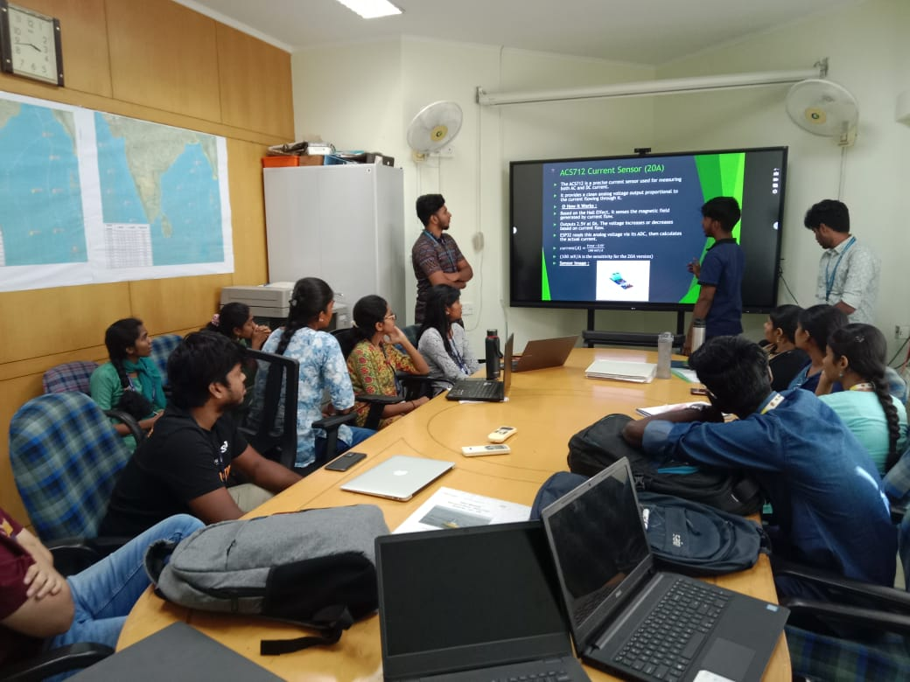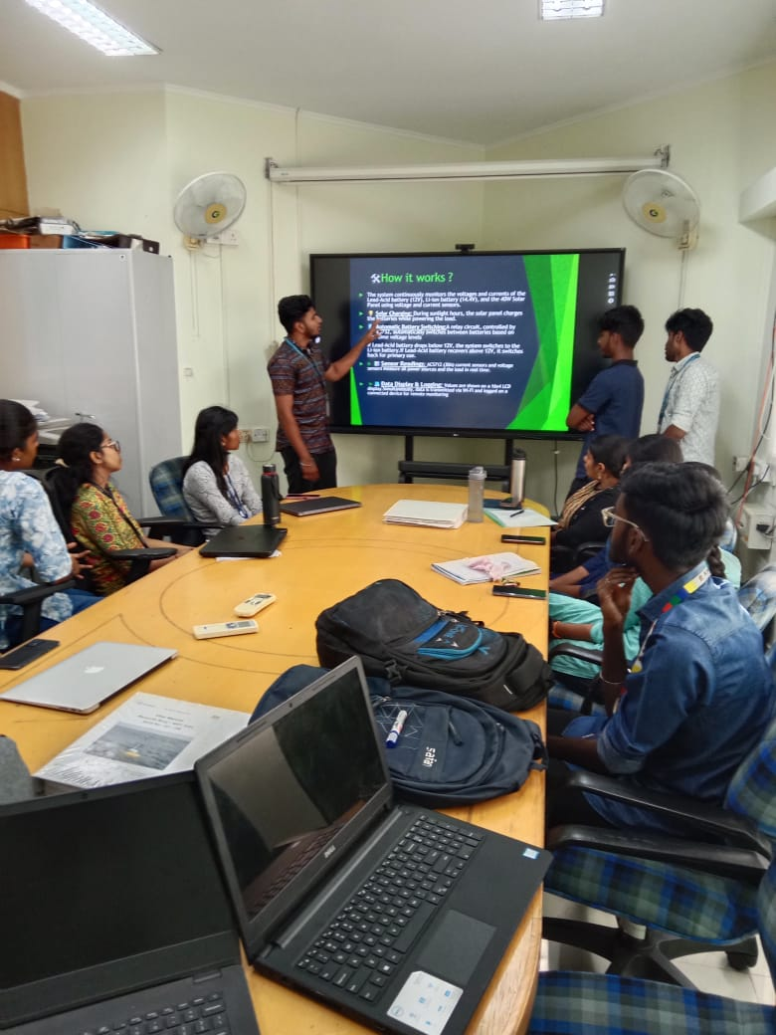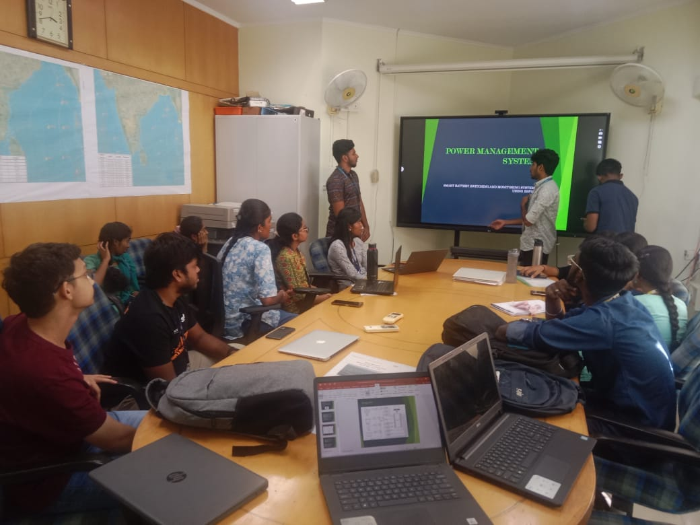

## **Chapter 11: Conclusion**

My internship at the National Institute of Ocean Technology (NIOT) under the Ocean Observation Systems (OOS) Department provided me with an in-depth understanding of real-time ocean monitoring and the critical role of technology in marine data acquisition. I was exposed to various aspects of buoy-based systems, which are used to collect oceanographic parameters such as temperature, salinity, pressure, wind speed, and wave height.One of the key highlights of my internship was working on the design and implementation of an embedded monitoring system using the ESP32 microcontroller. This included:

Designing a voltage and current monitoring system for multiple power sources such as lead-acid and lithium-ion batteries.Integrating voltage dividers, current sensors, and relay-based switching mechanisms.Developing and debugging embedded code to measure and display voltage/current readings.Understanding power regulation using buck converters and implementing safe load connections.Learning the importance of power efficiency, especially in remote, solar-powered buoy systems.In addition to hands-on hardware experience, I gained valuable exposure to real-time data acquisition techniques, sensor calibration, and the role of microcontrollers in ocean instrumentation. I also understood how data integrity, low power consumption, and system robustness are vital for devices operating in challenging marine environments.

This internship not only strengthened my skills in embedded systems, electronics, and ocean instrumentation but also gave me a glimpse into the real-world challenges faced by scientists and engineers working in marine technology. It helped me bridge the gap between academic theory and field-level implementation, and has motivated me to pursue further work in the field of ocean observation, embedded systems, and environmental technology.